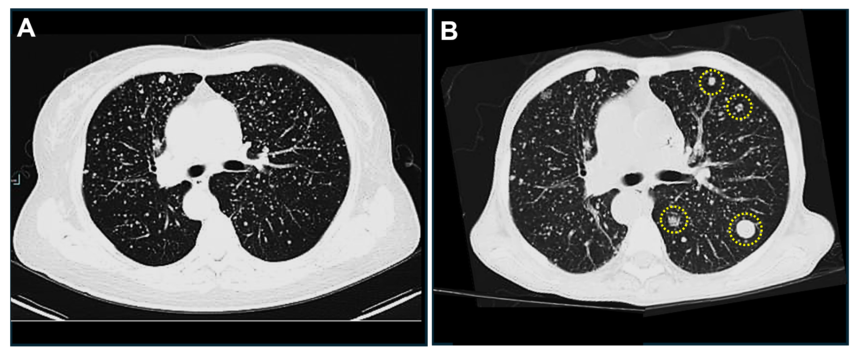
Suppl 3. Metastatic foci of uterine leiomyosarcoma were found in the lung tissue. Metastatic foci of uterine leiomyosarcoma are indicated by yellow dotted circles.

