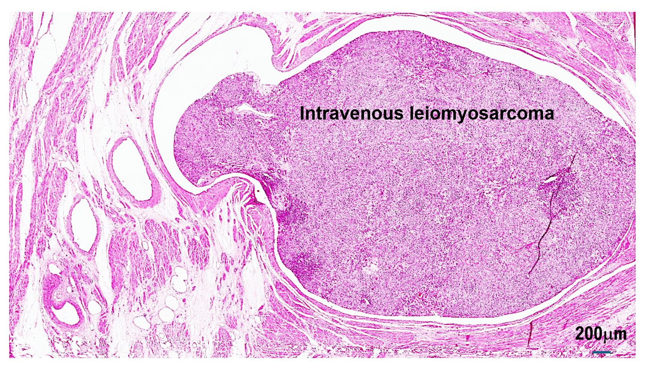
Suppl 2. Invasion of uterine leiomyosarcoma into the veins was observed within the tumor tissue of uterine leiomyosarcoma.

