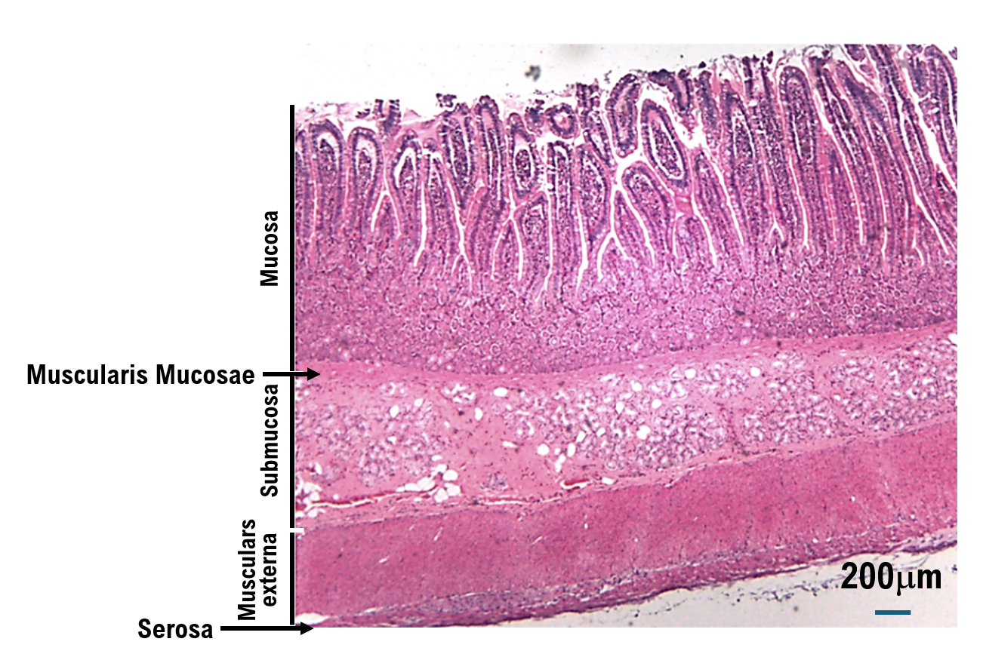
Suppl 1. No uterine leiomyosarcoma infiltration was observed in the ileum.

